**Deployment Code**

**Login Up and Log Out:**

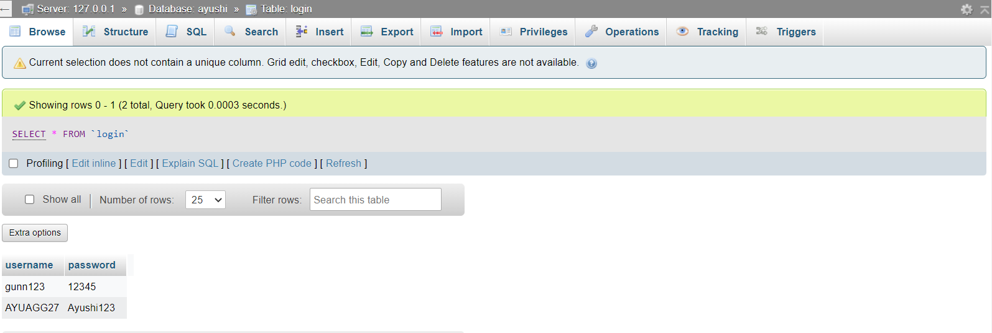

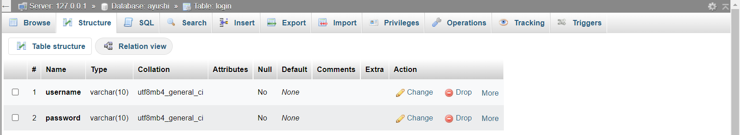

**Contact Us:**

